|  |
| --- |
| Base Information Technologies |

|  |  |
| --- | --- |
| UNIT | COSC2196 – Introduction to Information Technology |
| STUDENT NUMBER AND NAME | S3666690 – Andrew James Fraser |
| STUDENT NUMBER AND NAME | S3755544 – Damian Paul Dousset |
| STUDENT NUMBER AND NAME | S3853376 – Adam Matthews |
| STUDENT NUMBER AND NAME | S3858813 – Jack Wilson |
| SUBMISSION DATE | 26-05-2020 |

8550 words (total minus 400)

### TABLE OF CONTENTS

TABLE OF CONTENTS 2

1 base information technologies team profile 4

1.1 Personal Information 4

Damian Dousset – S3755544 4

Andrew Fraser – S3666690 4

Adam Matthews – S3853376 5

Jack Wilson – S3858813 5

1.2 Group Processes 5

1.3 Career Plans 5

Damian 5

Andrew 6

Adam 6

Jack 7

Compare and Contrast 7

2 Tools 8

2.1 Git Repository Audit Trail Accuracy 8

3 Project 8

3.1 Overview 8

Topic 8

Motivation 8

Landscape 9

3.2 Detailed Description 9

Aims – Shane (3-4 paragraphs) 9

Plans and Progress 9

Roles – Andrew 11

Scope and Limits – Andrew 11

Tools and Technologies – Andrew 11

Testing – Andrew 12

Timeframe – Andrew 12

Risks – Andrew 14

Group Processes and Communications – Andrew 15

4 Skills and Jobs 15

5 Reflection 16

5.1 Damian 16

5.2 Andrew 16

5.3 Adam 17

5.4 Jack 17

5.5 Group Reflection 17

6 bibliography and references 18

7 appendix 1 - ASSIGNMENT EXTENSION 19

8 appendix 2 - VERSION CONTROL HISTORY 20

9 appendix 3 - ASSIGNMENT 3 ARTEFACT 21

10 Appendix 4 - artefact references 24

# base information technologies team profile

## Personal Information

### Damian Dousset – S3755544

Nationality: Australian with Irish, Scottish, French and English heritage.

Hobbies: During my limited down time when I am not working, studying, helping raise our 3 children or coaching my children’s’ soccer teams I enjoy building wooden model ships, kayaking, camping and fishing.

I am interested in IT because I believe that it is an important subject to grasp moving into the future due to speed with which technology is influencing our work and private lives. On a more personal note I am excited by the prospects that AR, VR, robotics and AI offer to the future in the way we conduct business and are entertained.

When it comes to IT experience, I have always managed to understand the basics enough to get me by, from downloading and installing games, creating spreadsheets, regular use of excel and Microsoft word and occasionally PowerPoint.

### Andrew Fraser – S3666690

I am an Australian citizen living in Brisbane who works as a Supply Chain Manager for a Marine Construction company conducting projects around the world. I have worked around Australia, in Indonesia, Singapore, Egypt, Nigeria, Belgium and Germany.

I am studying a Bachelor of Business: Logistics and Supply Chain Management which I begun in mid-2016 and am in my final few units. In SP4 2019 I enrolled in Introduction to Information Technology as an elective, but was informed from student services that this unit was too similar to another compulsory unit and that if completed, I would not receive credit for IIT. Happily, the compulsory unit is not available until 2021 and IIT is the substitute unit!

Outside of work and study I am a novice powerlifter who was preparing for my first sanctioned meet in Sydney in May, which unfortunately looks like it will be cancelled.

My interest in IT was sparked as a teenager, through video games, and then again through the course of my career, having witnessed the growing capabilities and usage of IoT, among others, in industry. Particularly clear to me is the moment our Manager Director sent through the profiles of two IoT companies with the message “Find a useful application of these platforms on your project and report back to me”.

My experience in IT is reasonably limited, stemming from learning in studies and everyday professional activities. I am a competent user of the basic Office suite, have taken part in development of our proprietary ERP, entirely as a key user, and am a user of other data platforms, such as Power BI.

I chose to study at the Royal Melbourne Institute of Technology due to the major they offered, Logistics and Supply Chain Management. My choices at the time through distance learning was the Diploma to Professional Diploma pathway through the Chartered Institute of Procurement and Supply, a Bachelor of Business through RMIT, Griffith or UniSA, or the Bachelor of Business: Logistics and Supply Chain Management with RMIT. Due to the delivery method, specificity, learning pathways and career opportunities I decided upon RMIT and have never regretted the choice.

During the Introduction to Information Technology unit I expect to garner cursory knowledge about useful platforms and applications of IT. I still have one elective unit to complete and I seek to select a unit outside of my typical knowledge-base while still learning something with relevancy to my chosen occupation. Not having any experience with programming, my initial goal is to learn about the uses of programming, abilities and capabilities of different programming languages, and to reflect upon the useful applications of programming languages in my everyday professional activities.

### Adam Matthews – S3853376

I am a full-time student from Townsville, North Queensland who has moved to Brisbane for greater opportunities in the field of Information Technology, more specifically- Software Development. While I love all to do with computers, in my free time you will find me fishing, listening to music or intently following world sport, from Australian Rules Football to Formula 1 racing. A long term goal of mine is to one day be able to merge these pastimes with my fascination for software development in a professional setting.

My interest in the IT field is to be able contribute to technology in the fishing world, or be a part of a sports team or organisation that I have grown up loving. My fascination for software development sparked early in primary school when it was announced that there would be testing for North Queensland's first ever 'laptop class' in primary education. Having passed the test and been admitted into the class I was able to see in just two years how accessible and connected the world was becoming. Learning to create my first programs, and countless simple games afterwards, was where my interest truly flourished into fascination.

### Jack Wilson – S3858813

My name is Jack Wilson and I am from South Gippsland, Victoria. I moved down to South Gippsland in 2013 from Melbourne where I had been living since, I was born. I finished Year 12 with a VCAL Certificate. I didn’t do VCE due to health reasons, but I still wanted to go to university. Back in February I found out about this course at Open Universities. I am now a fulltime student at RMIT University who is working online. I am working towards ultimately getting a master's degree in Computer Science.

Interest in IT: My main interest in IT revolves around studying and working with the latest technology. Given my various disabilities, I have always been interested in robotics, self-driving cars and other such technology that will allow me to lead a more independent life.

Why did I choose to come to RMIT? The reason I chose to come to RMIT was because it offered the best course options regarding IT. A qualification in this degree will give me a broader range of job opportunities.

What did I expect to learn from my studies? From my studies I was mainly hoping to obtain broad spectrum skills around IT, more specifically learning skills that revolve around all different areas of programming.

## Group Processes

From assignment 2 it was identified that we had no version control of our assignment so for assignment 3 we placed greater importance on version control by utilising GitHub to a greater degree. This has allowed all members to store their work "off-site", increase tracking of changes and an ability to revert to previous work if required. Also for assignment 2, communication was deemed to be an issue so, while planning for assignment 3, steps were proposed to help alleviate this issue by seeking out information from each member as to how often they think they would be able to make time to discuss the assignment and be available for video recording for assignment 5.

## Career Plans

### Damian

Although a career as a Financial Planner/ Investment Analyst is a far cry from my current employment, I feel over time I have acquired some of the skills necessary for a financial firm such as setting goals, meeting deadlines, communicating with others, oral and written skills, multitasking etc. These skills, coupled with a natural interest in finance, a mathematically driven mind, and an eagerness to learn more about the finance field, make employment in the finance sector a natural choice.

Working in a large firm would likely require working in the CBD, in which case Brisbane or Sydney would be my ideal preferences with a small commute to work each day. With my current employment requiring routine and discipline I wouldn’t find it excessively different from that expected of a large finance corporation.

Although a change in career path at this stage would mean a drop in salary, by the time I switch jobs my wife will be back at work and all 3 children will be at school meaning we will be back on a dual income.

I am currently half way through my Bachelor of Business Degree. The next half of the degree will take approximately another 3.5 years which will align with our youngest daughter starting kindergarten and my wife resuming full-time employment. Once I have finished my degree, and before I leave my current job, I will seek out a Graduate investment analyst/ financial planner position where post grad experience in the field is desirable but not essential. Along with my business degree it will also be beneficial for me to have some experience with Microsoft Excel, so, unless already gained through my degree, I will also undertake an Excel course to brush up on my skills. Also, prior financially modelling experience is also often a requirement in the investment analyst field so I should also consider taking an elective that will give me this experience.

### Andrew

The desired position, Fleet Manager – Containers and General, is a management role based in Brisbane for a large multi-national company. It fits my experience in international freight, managing multiple sites with inventory, their own network of deliverables, and my experiences with large-volume cargo such as containers and irregular freight. It would require the applicant to manage operational and strategic goals, providing satisfaction in completion of tangible objectives, as well as significant higher-level strategy and process development, implementation and improvement. In addition, it is based in my home-town, ending a streak of 9-years of location work and it is with a well-known, reputable organization with room to climb.

The applicant needs developed analytical and logistical reasoning skills, high-level people management competencies, as well as significant expertise in supply chain network operation, analysis and design, particularly with heavy experience in multi-modal sea, road and rail freight. The applicant would have 15-20 years of industry experience, with proven experience in the role, although perhaps in a smaller-scale operation, and a Master of Logistics and Supply Chain Management.

This position is a 5-10-year goal for me; I have 10 years of industry experience, with 5 years of experience at a national level in operation, analysis and design of multi-million dollar supply chains, compared to billion-dollar supply chains operated by the Toll Group. I am, with luck, within 9 months of completing my Bachelor level qualification in Logistics and Supply Chain Management and already possess Diploma’s in Procurement and Supply and Workplace Health and Safety.

In the next 10 years I will work toward my goal through continued professional development. I will finish my Bachelors and after a period of 6-12 months, in which I will pay off my student debt, I will enrol in the Masters of Logistics and Supply Chain Management through RMIT. I will proceed with this at half pace, aiming to complete the Masters in 11 study periods, or 3 years.

I will continue to seek professional challenges in my work, taking on activities I have not conducted before and setting ambitious objectives for the units under my purview. In the mean time I may seek employment in a company in which I believe I can advance my career prospects, either through exposure, reputation or experience, such as taking on a Project or State Procurement or Supply Chain Management role with a tier 1 company based in Australia.

### Adam

An example of my ideal job in IT would be a software developer in the research and development field for and organisation such as Renault Sport Racing. This particular advertisement demands a candidate that can make results from varying modes of testing available to engineers in an organised and streamlined approach. Ultimately, this position would give me the opportunity to play a significant role in developing the car. Having the ability to contribute to a potential Formula 1 World Championship is what makes this position truly appealing to me.

The skills that are required for the position include; exceptional proficiency in Python and JavaScript programming languages, as well as the ability to use a number of programs for building user interfaces. It is also a requirement of the candidate to be able to accommodate the real-time communication of data through libraries such as Socket.IO. No essential qualifications have been identified by the team. However, the applicant must have several years of experience in writing applications in a professional environment and a thorough knowledge of web databases.

I currently do not possess any experience practicing software development professionally, nor do I possess any valid qualifications yet. Further, my skills in the appropriate coding languages and in online database services are very minimal. Any skills I have gained in this area have only come from nearly one month of study and casual experimentation in my own time.

To obtain these skills I must, as a minimum, be an active participant in every area of my studies. Including not only the technical aspects, but also participating in the parts that will teach me to excel in a professional team-oriented environment. To make this position truly realistic to me however, I will have to practice my proficiency in creating my own projects outside of just the university, as well as keep up to date with all the relevant languages and systems as the IT field continues to grow and expand. Even though this particular position doesn’t require any specific qualifications, it is likely that similar jobs in the future will. This will drive me to gain as much accreditations as I can, starting with a university degree. Further, gaining as many possible qualifications will only hold me in good stead for any future prospects. Lastly, I will gain the experience needed over years of relevant professional work. This will start at entry level and include simple tasks such as maintaining, testing and debugging; and will grow into more complex projects. This technical experience will also be complimented by my growing confidence in a professional, team environment as a result.

### Jack

My ideal job is a job as a Software Engineer at Google. This job requires you to develop software for the company and it will see you work with Google’s next generation software and hardware. I have always wanted to work at Google, and with an aspiration to be a software developer, this job is highly appealing to me. This position also comes with a good salary of approximately $109,368 AUD per year.

Minimum Qualifications:

* The minimum qualification required for the job is a Bachelor's degree in Computer Science or related degrees, or similar level of past experience.
* 4 years of work experience in software development.
* Experience and knowledge with C, C++, Java or Python.

Preferred Qualifications:

* The preferred qualification for the job is a Master’s degree or PhD in computer science or related degrees, or similar level of past experience.
* Experience in two or more main stream programming languages such as C, C++, Java etc.
* Strong interest in programming.
* Excellent written and verbal communication skills.

I do not currently meet any of the qualifications required for the job. However, to reach all the required qualifications, my plan is to first complete my Bachelor’s degree including all the minor studies with a GPA of at least 2.0 out of 4.0. Upon completion of my Bachelor’s degree, I aim to study my Master's Degree in Computer Science on a part time basis whilst working in an IT position at the same time. This will enable me to get the 4 years’ work experience required for the position. Once I have at least 4 years of work experience in a position in the field and have completed the Master’s degree, I will then have met the qualifications I feel are necessary for the job (Royal Melbourne Institute of Technology)

### Compare and Contrast

Each career plan follows a similar structure, in that it’s foundation is formal education, more specifically an undergraduate or graduate pathway beginning with RMIT. Two of the ideal jobs are within the IT sector and begin in the same place, with an undergraduate degree in Information Technology. All of the career plans include further education, two of those moving on to Masters level education and all seeking additional formal skills training through other private institutions.

Half of the ideal jobs are in the IT sector, one in the Financial section, and one in Logistics and Transport Services. The required skills and experience are quite different, even within the IT sector. Half of the career plans are for mature-aged students who have significant work and life experience; therefore, their career plan is more developed.

The two IT related jobs require experience with programming languages of some kind, yet given the difference between the desired applications (cybersecurity, development of software for Google, development of software for sports racing), this proves the vastness of opportunity that IT offers.

One of the career plans represent a progression in a similar field (Andrew- Fleet manager), one represents a completely different occupation all together (Damian- Financial Planner/ Investment Analyst) and the rest represent an opportunity to enter the workforce (Adam- Software Developer, Jack- Software Engineer).

# Tools

Website link: <https://group-a2-team-6.github.io/Intro-to-IT-A2-Team-6-Assignment-2/>

Git repository link: <https://github.com/Group-A2-Team-6>

## Git Repository Audit Trail Accuracy

The GitHub Audit trail accurately represents the final culmination of the project. Although over time greater experience could be obtained using the software, it has served its purpose as a back-up of data and place where numerous members can come together and work on the same project. The repository audit trail can be found in Appendix 2.

# Project

## Overview

### Topic

With 5 million recreational fishers in Australia, the sport of fishing remains relatively untouched when it comes to IT, specifically smart phone apps. The purpose of this project is to create a mobile based fishing app targeted at recreational fishermen for both IOS and Android systems and will be limited to Australian states and territories. The app will drive a social atmosphere and will include the ability to share photos and chat about fishing.

The aim of the app is to increase the popularity of recreational fishing in Australia, make recreational fishing more socially oriented and, through sustainability and waste recovery, support the health of Australian waterways to ensure recreational fishing is kept alive well into the Australia’s future.

While also incorporating data from weather and tidal apps, the app will also be driven by data uploaded by recreational fishers in regards to what types of fish are caught in different locations, the best tide times when the fish have been caught and even recommended bait or tackle configurations.

### Motivation

There are 3 main motivations behind the project in bringing technology to the sport of fishing. The first of which is to make the sport become more socially focused, by linking various social media platforms to the app. The second is to increase fishing as a popular pastime by making successful fishing spots, methods, gear and times more established, especially beneficial in getting recreational fishers to take up the sport. The third reason for the push for technology is to collect and make data from the app available to assorted Australian agencies for the purpose of stocking of fish in certain areas based on the popularity, to the CSIRO (Commonwealth Scientific and Industrial Research Organisation) in order to gain an insight into fish populations and migrations over a long period of time, and to local governments for the purpose of the recovery of waste such as chemical drums, car tires and whitegoods from Australia’s water ways.

The current IT trends include the increase of mobile technology and the popularity of social media in the day-to-day lives of Australians. Technology is especially relevant to the sport of recreational fishing where people need to: use maps to search for fishing spots, google where to purchase bait and fishing equipment, purchase a fishing license depending on which state they live in, check to see what the weather and tides are like, look for tips on how to catch certain species of fish, and many other reasons.

To work on this project would show to a future employer that we as individuals are able to both undertake individual research on a set topic and also work together as a group to compile a report while having an understanding of relevant IT software and methods.

### Landscape

There are numerous stand-alone apps on the market for fishing related activities including: Social media, tides, weather, maps, lunar calendars, fish identification, fishing knots and many others.

There are about 10 competitors in the market, the most popular of which, Fishbrain (Fishbrain n.d.) has over 5 million users worldwide. With the most popular Australian apps having about 100,000 free and 10,000 subscribed users.

The main competitors for the app would be Fishbrain and Australian based apps: “Fishing points- Fishing app” (Fishing Points 2020) and “Fishing spots” (Fish Angler n.d.). These apps all feature similar functions such as: a map indicating where fish have been caught, a social media feed, a weather forecast, the ability to upload a catch, a fish species database and a virtual tacklebox.

This app differs from the current apps due to the environmental and sustainable elements that no other apps currently offer, with the ability to report dumping and providing data to government agencies for sustainability. Additionally, what will set the app apart is ease of use, functionality and ability to link seamlessly with a wide range of social media platforms. The app will also be able to digitally hold current state drivers’ licences, fishing licences and marine licences and will also show the closest fishing tackle/ bait suppliers and operating hours something that the other apps don't do.

## Detailed Description

### Aims – Shane (3-4 paragraphs)

Text

### Plans and Progress

At its most basic level, iCatch is a smartphone app that will assist recreational and licenced fishermen in a number of ways. The application will take an accessible and easily manageable form and allow users to; mark fishing spots by location and store relevant data, connect with friends and fishing professionals, and suggest new locations for users based on collected data and the users’ chosen fishing method. Additionally, the app will include the ability for recreational fishers to report illegal dumping such as car tires and white goods so often seen in water ways during fishing.

The ability to mark specific locations via GPS and collate masses of information will be the main feature that the app is then built around. The information amassed will be made accessible to the consumer in a well presented and user-friendly manner. This information will be gathered automatically by the program from various websites and data agencies. The data that will be collected by the program will not be limited in the future. However initial data types will include; the location of fish where they are caught, the tide (and its size), water temperature, currents, time of day and weather conditions. Data that cannot be collected automatically will require user inputs and will incorporate such entries as; the type (and size) of fish, the tackle used, how accessible the location is, water depth, as well as the depth where the fish was caught. Other data supported by the app will be things such as dates and pictures.

Rather than simply storing the data, this program will then feed it back to the user based on specified filters or smart suggestions. This could work two ways; firstly, by allowing the user to search for a specific fish. This will return various locations within a certain radius (specified by the user) where these fish have been caught in volumes. Preferred bait, optimal tides (when they feed in the cycle, incoming or outgoing, etc.) and most successful tackle will all be returned to the user to give them the best chance of catching their target fish. Secondly, a user could instead choose to enter a location, rather than a target fish. This would then return what fish are likely to be caught at that spot and the equipment then needed. This will be done all while taking into account the weather, time of day, and the season.

Another feature that excites the team and distinguishes our program is the addition of a social aspect. This would allow users to follow friends or public figures allowing them to share locations, catches and discuss information with each-other. This would also allow existing fishing charters to charge subscription fees for information such as fishing spots and tips through our application.

An additional feature proposed by the team aims to set a sturdy foundation in social responsibility. Within one year from launch the team aims to give the app the ability to supply captured data to the Department of Primary Industries and the CSIRO for fish migration data and Australian state agencies for the purpose of fish stocking programs.

The application will rely heavily on GPS and data storage technologies upon launch. While these features have become relatively easy to create and manage in recent times, it is imperative that the team follows a strict plan for protecting this data. For it plays such an essential role not only in the effectiveness of our program, but in whether or not people are comfortable with the brand. This will mean that prior to the launch of the app, the team must have enlisted the service of a skilled developer with refined expertise in web and data security to ensure the app is manageable and secure at the time of launch.

The programs greatest feature will undoubtedly be its ability to, rather than just store information, feed it back to the user based on specified filters or ‘smart suggestions’ using aspects of machine learning. We expect machine learning to be the most challenging aspect of developing the program. In saying that however, we understand that our app, like others, will never be ‘complete’ and it certainly won’t contain an advanced AI system at launch. It is our intention to continue to grow our capabilities as developers as the application grows in complexity. This ultimately serves as our plan to build an extremely accessible, data orientated app.

The application began as a single idea and was soon adopted and expanded on heavily by the team. In a rapidly expanding world of information systems it was noticed that there was only few aspects of modern life that weren’t already consumed by technology. Although the team is passionate about fishing, it was the amount of people who enjoy recreational fishing, and the lack of great competition in this market that lead the group to really pursue the program.

At present, iCatch is still in its design stage (see artefact at end). The team will aim to launch the app with minimal basic features and grow exponentially, adding the rest in time with a larger budget and a larger team of developers. While these features are fundamental and important to iCatch, they are only initial features and it is unknown what possibilities will be made available and what ideas will be had in the future.

Initially the app will be built for IOS and Android devices. This means there are a number of necessary tools and technologies required to build and accommodate the program in the future. The software required to build the IOS app includes the Apple Xcode toolkit. For the Android app, programs such as Android Studio or Eclipse are needed. The data collected by the app will be centralised as we aim make the most of cloud computing, limiting requirements on the consumer end. The hardware requirements on our end consist of, as a minimum, a device capable of comfortably running software development kits.

The skills required by the team to build and maintain the application as a whole are great competence in both Swift and Java programming languages. Furthermore, strong skills with various aspects of cloud computing are also necessary. More specifically, database skills and developmental operations proficiency.

It is crucial that the team gains these necessary skills and invests in the required tools. It is also acknowledged that more developers will also be needed in the future to cope with growth, and to also provide even more ideas.

### Roles – Andrew

Roles for the app’s development have been loosely assigned and are based around the potential hierarchy of a project. The roles have been assigned based on the aspirations and skills of the team members but are not fixed, nor do they wholly define the roles and jobs undertaken by each team member. The roles are as follows:

* Project Manager – Damian Dousset
* Lead Developer – Adam Matthews
* Content, Marketing and Finance – Andrew Fraser
* Developer – Shane Gillespie
* Developer – Jack Wilson

Damian has been selected as the Project Manager. It is a role he naturally fills, instinctively developing structure, initiating brainstorming, and taking ownership over setting and meeting goals. Adam is the logical choice for Lead Developer as it is an evolved version of his initial project and maintains much of the original function and aim from that first concept. Pair this with his aim to be a software engineer for the Renault Formula 1 team and the position of Lead Developer for the project is an admirable position to fulfil and something he can add to his portfolio. Content, Marketing and Finance falls to Andrew Fraser, as he is completing his Bachelor of Business - Logistics and Supply Chain Management he has completed two finance units and one marketing unit. Although in the long run these two functions may be outsourced or conducted by new hires, his knowledge in these areas will give the project a running start. His primary responsibilities, outside of coding and development, will be seeking commercial partnerships and forming key strategic relationships. Shane Gillespie and Jack Wilson will take on Developer roles, primarily involved with creation of the app under the direction of the Lead Developer. This includes involvement with creating applications and functions processes, improvements, maintenance and programming, as do all the other roles.

### Scope and Limits – Andrew

The objective of this project is to create a fishing app with the capability for users to identify ideal fishing spots through the input of other users who have created a sort of tag at the location which marks the location with some input data through set filtered fields. The scope for the project has been defined as creating the user interface, the interface with Open Street Maps, the updated maps, the user chat, the contact interface between Service Provider and user, the reporting function for the social responsibilities aspect, and the “report a problem” function between users and developers.

To avoid “scope creep” it is important to also define what aspects of the application will not be within the scope for development. The map will not be created; Open Street Maps is an api available for all developers and is an evolving map of the world (cite). Already a lot of mobile applications offer the ability to link google, facebook or other social media accounts to the applications user account. This is offered through the (XX function) (cite) and as such this function is not within the scope for development. Information filters will be used in the application, the development team will use (XX function) (cite) which is available to all developers.

### Tools and Technologies – Andrew

Typically apps for different operating systems require different programming languages. In most circumstances those languages are Java and C++ for Android and Swift ( ) and Objective C for iOS ( ). As none of the group members are particularly skilled or experienced with any programming languages, it is in the best interests of the project to adopt lean principles for the human resources and maximise efficiency of effort. As such the project will adopt the source code app user interface Xamarin.FORMS, which allows users to create applications for both Android and iOS using C# as the programming language (Microsoft 2020) (G2 2020), and bridges gaps using the platforms existing protocols. Pricing for an enterprise is $1,899 USD for one year’s license (G2 2020).

Additionally, there will be a number of .api’s required for such app functions as filters, etc. although these will likely be recruited from open source code to reduce the amount of original content creation (look for filter api’s) (cite). If licenses are required for access to source libraries this will be assessed on a case-by-case basis through a needs analysis.

### Testing – Andrew

Testing is a critical component in app creation to ensure that the logic and the process flows translate correctly to the manifested app. Each function should be tested on an Android and iOS platform to guarantee that users can immediately enjoy the full use of the app upon release without conflicts or errors. However, with limited resources and limited time, user testing after each additional function to determine the impact on all existing applications is a very time-consuming process. Therefore, testing will be conducted for new functions as the app is developed through a process of “builds”, beginning with v0.1.

User testers will be selected from the project team as well as an additional 2-5 testers from outside of the project team. The testers will be selected on the basis of development knowledge and experience, along with the type of mobile device the tester owns. For the maximum exposure as broad a spread as possible of popular brands should be covered, including brands such as Samsung, Apple, Huawei, Nokia, Sony, Google and OnePlus. A higher level of app or programming expertise to thoroughly assist with useful feedback. Fishing interest is a minor factor as content creation is the responsibility of the project team and the scope and available resources do not allow for further function or content to be developed prior to release. Post-release, depending on how well the app functions, feedback and interest, further development can be considered, further resources assigned and the testing program expanded accordingly.

iCatch will be tested with three “test builds” and one “release build”. With each test build releasing more functionality and rectifying issues detected in the previous round of testing. As such the testers and developers should be prepared for three rounds of testing prior to the initial release at the end of the 16-week project.

### Timeframe – Andrew

The project has been in progress for nearly 6 weeks by the publishing of this report and progress has been solid. In the early weeks the team was given easily achievable goals, whereby the individual members could reset from the build-up of stress from assignment 2. During this time the main focus was on the app layout and mock-ups were produced by Damian, with review and feedback from the other group members. Weeks 4-6 heavily focused on the presentation script, presentation filming and making decent strides into the report progress.

Weeks 7-16 of the project timeline will be heavily focused towards app development; programming, testing builds, and creating the sought-after commercial partners. An abbreviated timeline can be seen below:

|  |  |  |  |  |  |
| --- | --- | --- | --- | --- | --- |
| Week | Damian | Adam | Andrew | Jack | Shane |
| 1 | Topic. Create app layout and create demonstration for presentation. | Create plan and detail progress. App layout brainstorming. | Define roles. App layout brainstorming. | Analyse career plans. App layout brainstorming. | Define aims. App layout brainstorming. |
| 2 | Motivation. Create app layout and create demonstration for presentation. | Create plan and detail progress. App layout brainstorming. | Define scope and limits. App layout brainstorming. | Analyse career plans. App layout brainstorming. | Define aims. App layout brainstorming. |
| 3 | Landscape. Create app layout and create demonstration for presentation. | Create plan and detail progress. App layout brainstorming. | List tools and technologies and set time-frame. App layout brainstorming. | Analyse career plans. App layout brainstorming. | Define aims. App layout brainstorming. |
| 4 | Assist to create and review script. Finalise app layout and create demonstration for presentation. | Create plan and detail progress. Assist to create and review script. | Determine testing protocols and detail group processes and communication. Assist to create and review script. | Assist to create and review script. Analyse career plans. | Define aims. |
| 5 | Revise and finalise script and storyboard. Film presentation. | Create plan and detail progress. Film presentation. | Detail Risk. Film presentation. | Analyse career plans. | Define aims. |
| 6 | Complete reflection. Finalise editing of presentation video and submit. | Complete reflection. Create plan and detail progress. List skills and jobs. | Complete reflection. Finalise report and website and submit. | Complete reflection. | Complete reflection. |
| 7 | Assist market analysis. Manage timeline and goals. Development. | Content brainstorming. App program and development. Liaise with PM and Marketing and content. | Begin market analysis and identify potential strategic partners. Book-keeping. Create Budget Control Report. | Development of application | Development of application |
| 8 | Review market analysis. Manage timeline and goals. Development. | Content brainstorming. App program and development. Liaise with PM and Marketing and content. | Complete market analysis and approach potential partners. Book-keeping. Update, review and report on Budget Control Report. | Development of application | Development of application |
| 9 | Assist partner negotiation. Manage timeline and goals. Development. | Content brainstorming. App program and development. Liaise with PM and Marketing and content. | Continue negotiation with potential partners. Book-keeping. Update, review and report on Budget Control Report. | Development of application. Finalise sections for testing. | Development of application. Finalise sections for testing. |
| 10 | Manage timeline and goals. Development. | Manage testing program. Review feedback and set corrective actions. | Select viable partners. Book-keeping. Update, review and report on Budget Control Report. | Development of application. Update application from testing feedback. | Development of application. Update application from testing feedback. |
| 11 | Manage customer relationships. Manage timeline and goals. Development. | Manage testing program. Review feedback and set corrective actions. | Manage customer relationships. Content brainstorm and testing. Book-keeping. Update, review and report on Budget Control Report. | Development of application. Release follow-up test build. | Development of application. Release follow-up test build. |
| 12 | Manage customer relationships. Manage timeline and goals. Development. Testing | Manage testing program. Review feedback and set corrective actions. | Manage customer relationships. Content brainstorm and testing. Book-keeping. Update, review and report on Budget Control Report. | Development of application. Update application from testing feedback. | Development of application. Update application from testing feedback. |
| 13 | Manage investors and prepare for release. Manage timeline and goals. Development. | Manage testing program. Review feedback and set corrective actions. | Manage customer relationships. Content brainstorm and testing. Book-keeping. Update, review and report on Budget Control Report. | Development of application. Release test build with further functionality. | Development of application. Release test build with further functionality. |
| 14 | Manage investors and prepare for release. Manage timeline and goals. Development. | Manage testing program. Review feedback and set corrective actions. | Manage customer relationships. Content brainstorm and testing. Book-keeping. Update, review and report on Budget Control Report. | Development of application. Update application from testing feedback. | Development of application. Update application from testing feedback. |
| 15 | Manage investors and prepare for release. Manage timeline and goals. Development. | Manage testing program. Review feedback and set corrective actions. Preparation for production release. | Manage customer relationships. Content brainstorm and testing. Book-keeping. Update, review and report on Budget Control Report. | Development of application. Release final test build with full functionality. | Development of application. Release final test build with full functionality. |
| 16 | Manage investors and prepare for release. Manage timeline and goals. | Manage testing program. Review feedback and set corrective actions. Preparation for production release. | Manage customer relationships. Content brainstorm and testing. Book-keeping. Update, review and report on Budget Control Report. | Troubleshooting and maintenance of application. | Troubleshooting and maintenance of application. |

### Risks – Andrew

The project objectives are at the far end of ambitious, to the point they project can absorb very few delays to maintain the project timeline. Within this time the Xamarin.FORMS platform must be secured, the application programmed using a programming language none of the project members have experience with, use of a few unfamiliar .api’s to facilitate projected functions, and the integration with Open Street Maps created in addition to forming strategic partnerships with service providers in the industry.

Difficulties in licensing the necessary source code interface, learning the programming language, failures of the source code to provide the expected benefit or delays in securing strategic partnerships can all result in delays of the deliverables and potential delays to the overall project. A delay in the project may result in a loss in investor confidence, or a loss in the consumer interest, in addition to the potential to higher with overheads costs and jeopardise the budget.

Recruiting the appropriate testers may be a risk. There are little resources to incentivise testers and therefore engendering sufficient buy-in from the ideal testers may be problematic. At worst case this may also create a delay in the project delivery, or result in unexpected errors after app launch resulting from conflicts which should have been detected and rectified during the testing. This may impact the reputation and therefore the overall success of the project.

### Group Processes and Communications – Andrew

Group communication was solid through assignment 2 although, as always, with some room for improvement. Microsoft Teams group chat is the main communication platform as it is the most versatile. Teams can be operated as a web or mobile app and is designed as a commercial work platform and therefore allows file storage, meeting planning, and voice and video meetings and conferences. Zoom was also used for the rehearsal and recording of the group presentation, although these sessions were scheduled using Teams. The presentation would have also been conducted through Teams, however Zooms in-built recording functionality made the need for an additional recording program, such as OBS, redundant.

No formal meetings were scheduled, outside of the presentation rehearsals and recording, due to time-zone differences and availabilities of the individual group members. Collaboration and brainstorming was conducted more informally through Teams group chat.

Allocation of work was divided on a voluntarily basis, assuming correctly that individual responsibility would encourage members to volunteer for sections with a relatively fair division. To a surprising degree this method was successful, although some group members did take on a greater workload, dividing up outstanding sections among the more organised group members. Work allocation was divided and recorded using a Gantt chart in excel, with an approximate workload and duration included to assist in a fair division. The Gantt chart can be observed below.

In addition, GitHub was used a lot more for file and version storage by the group after recommendation in the feedback from Assignment 2. A new repository for Assignment 3 was created and all shared files were stored in GitHub. However, one member working on location had his personal laptop destroyed when a tree fell through the house in a storm on the weekend Assignment 2 was due. As such all shared files were also stored on Teams to ensure all members had easy access, although this required discipline in communication to ensure the integrity of version control was maintained.

# Skills and Jobs

An app with the proposed size and scope of iCatch requires a variety of different roles and skills within a team to efficiently and effectively develop the application. These include but are not limited to: user experience designers, business analysts, quality assurance testers and developers.

Because we are presenting both a product and a brand, a user experience designer would be an essential addition to our team. UX designers are responsible for the overall accessibility of the app (Puolitaipale 2019). As recreational fishers come from all walks of life, an accessible and easy to operate interface is crucial. An ideal candidate for this position would be extremely team orientated as well as an innovative thinker.

Business analysts serve as central links between forms of management, stakeholders, developers and customers (Tonex 2020). This role is necessary to articulate intricate and important information and then communicate it to the relevant people. While a candidate for this role is not an immediate priority within the team, it will become increasingly important as the brand and technicality of the product grow.

Quality assurance testers are required to make certain that apps are ready to release to consumers (Job Hero 2020). Further it is their responsibility to continue debugging and testing programs as they continue to grow. This is the exact role that a QA tester will need assume in our team. As this role is so important and is requires close work with developers it will need someone with strong leadership qualities and interpersonal skills.

Lastly, developers carry out the majority of the work in building the application. Developers are responsible for writing the code and are also encouraged to present and implement ideas (Puolitaipale 2019). Along with UX designers, the developers have the most important role in the creation and maintenance of the app. Both technical skills and the ability to work in a team will be most important qualities when looking for the ideal candidate. Such is the importance of their role in programming the app and within the wider team.

# Reflection

## Damian

Much like assignment 2, I found Microsoft teams was useful for regular communication, brainstorming ideas and uploading documents that didn’t require any kind of version control, this was especially evident as Microsoft teams has a phone app available which makes it easier to be notified of any messages.

Towards the end of assignment 3, as all the parts came together, GitHub was used in a rudimentary form to allow for visibility and tracking of changes. With regular use of GitHub by all members working on an important project over a long period, I’m sure GitHub would be greatly beneficial to avoid loss of man hours in certain circumstances that would prove costly to an organisation.

Despite differing time zones, most of the team were able to keep up regular communication and were available to put forward their ideas to the group. Even with the Coronavirus pandemic and natural disasters the group has managed to put together a great looking final product and I’m really happy with how it’s turned out.

## Andrew

Most group members at this late stage of the unit have a reasonable report and level of understanding. Therefore, the forward thinking and collaboration between group members was very positive. Each active group member took initiative at certain points to take upon themselves work that bettered the overall product. For example, Damian took the presentation upon himself early and without seeking advice he produced quite a good product, seeking group feedback when the task was mostly completed.

Use of Git repository could be improved. Because of familiarity and the ease of Teams group chat, it was maintained as the collaboration and file sharing platform. However, after feedback from Assignment 2 it was determined by the group to promote GitHub utilisation, leading to significant duplication of effort which potentially endangered the integrity of the repository’s version control with the same files stored and updated in two locations. Unfortunately, this was more or less unavoidable, with one member unable to use Git through unforeseen circumstances.

The drop off of buy-in from some group members at this late stage of the unit was surprising. A significant drop in participation was noted from one group member in particular, which was disappointing to see. However, the assignment delivery was never in question thanks to the forethought and planning of the active group members.

## Adam

Upon reflection I feel that my communication improved compared to the first group assignment. This came through both a better understanding of Microsoft Teams and its features, as well as growing familiarity with the group members.

There was great room for improvement however as I believe my time management was not quite as efficient as it could have been. The work I took on was completed before the deadline and to a decent standard. However, I would have liked to have had it done far earlier to make it fair on the rest of my group who were trying to utilize as much time as they can for formatting and dealing with late unexpected problems, which proved to be somewhat of an issue during the last task.

I was pleasantly surprised with the overall drive and commitment of the group given we are coming to the end of a long study period given the countless external pressures due to Covid-19 and the very foreign way of living that comes with it.

## Jack

What went well: We worked collaboratively as a team and got a lot done in terms of workload, doing especially well with the first group assignment (task 2) achieving 75 out of 100.

What could be improved: Maybe a little better time management since we did need to ask for an extension with the 2nd group assignment (task 3). However overall, I believe generally we did the best we could in the time provided.

At least one thing that was surprising: We achieved higher results than I had anticipated, given that it was a group assignment and also the first time I have worked in a group online at uni.

At least one thing that you have learned about groups: You have more knowledge and experience to draw on in a group compared to working individually. A good example of this being the programming of our fishing app for task 3 where one of our members had more experience in this area.

## Group Reflection

Overall, as a group the two assignments were very successful. Having a more mature aggregate may have played a part with that but the line between individual responsibility and team cohesion integrated to great effect. Many group members stepped up to take overload from members that were struggling for various reasons in pursuit of the overall team objectives. Unfortunately, due to turbulent global and national circumstances, there have been significant disturbances to group members personal lives, which has impacted their ability to focus on the group project.

On the whole the group communication has been quite solid. Individuals did not feel the need to broadcast every action they take towards their tasks, but the communication was relevant, frequent, informative, and collaborative. The overall use of GitHub repository could have been improved, as it is a project requirement and the version control features are useful. However, unforeseen circumstances would have forced a work-around for one member, and therefore the flexibility and ease-of-use Microsoft Teams was retained for Assignment 3.

Surprisingly, despite the horrible reputation of group work, working with this Team has been an altogether pleasant experience. Unfortunately, we had a late assignment group member withdrawal with no notice, but again all active group members stepped up to take the slack. In most circumstances the work has been distributed relatively evenly, responsibility taken up by each group member and the work completed in good time, with no last-minute rush to submit or penalties resulting from late submissions. Although the take-away for each group member is that in future groups, assigning early section deadlines allows for a buffer to take up any slack that arises or to complete any troubleshooting of issues , such as formatting on the website.

# bibliography and references

Australian Bureau of Statistics 2003, *Year Book Australia- Recreational fishing*, ABS, Canberra, viewed 18 April 2020, <https://www.abs.gov.au/AUSSTATS/abs@.nsf/Previousproducts/BAFB91C589D0706FCA256C AE0015CAA9>.

Bedell, C 2013, *Mobile apps development: Defining requirements is a whole new ballgame*, TechTarget, 25 February, viewed 20 April 2020, <https://searchsoftwarequality.techtarget.com/ feature/Mobile-apps-development-Defining-requirements-is-a-whole-new-ballgame>.

Emani, KK 2019, *The Top Cloud Computing Skills You Need to Pick Up This Year*, Simplilearn Solutions, 24 December, viewed 20 April 2020, <http://simplilearn.com/top-cloud-computing-skills-article>.

Fishbrain n.d. Fishbrain AB, viewed 11th May 2020, <https://fishbrain.com/>.

Fish Angler n.d., *Fishing Spots- Local fishing maps and forecast,* viewed 11 May 2020, <https://home.fish angler.com/about/>.

Fishing Points 2020, *Fishing Points*, viewed 11th May 2020, <https://fishingpoints.app/>.

G2 2020, Xamarin.FORMS, G2.com, Inc, viewed 18th May 2020, <https://www.g2.com/products/xamarin/ pricing>.

Job Hero 2020, *QA Tester Job Description*, Job Hero limited, viewed 25 May 2020 <https://www.jobhero.com /qa-tester-job-description/>.

Microsoft 2020, Xamarin, Microsoft, viewed 18th May 2020, <https://dotnet.microsoft.com/apps/xamarin>.

## Puolitaipale, T 2019, *The Roles of a Mobile Application Development Team*, 17 July, viewed 25 May 2020, <https://www.atimi.com/the-roles-of-a-mobile-application-development-team/>.

Tonex 2020, *Mobile Applications Business Analysis | Development Requirements*, Tonex Training, viewed 25 May 2020, <https://www.tonex.com/training-courses/mobile-applications-business-analysis/>.

V, N & Z, A 2019, *What’s the Best Tech Stack for Mobile App Development?*, RubyGarage, 6 January, viewed 20 April 2020, <https://rubygarage.org/blog/technology-stack-for-mobile-development>.

# appendix 1 - ASSIGNMENT EXTENSION

# appendix 2 - VERSION CONTROL HISTORY

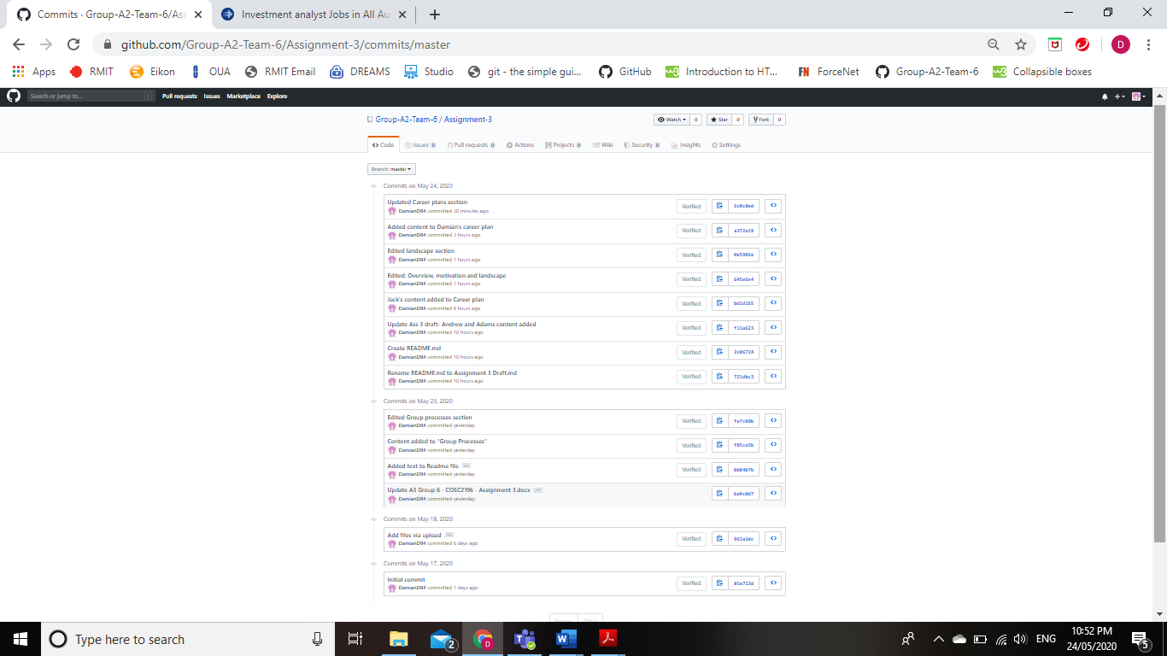

# appendix 3 - ASSIGNMENT 3 ARTEFACT

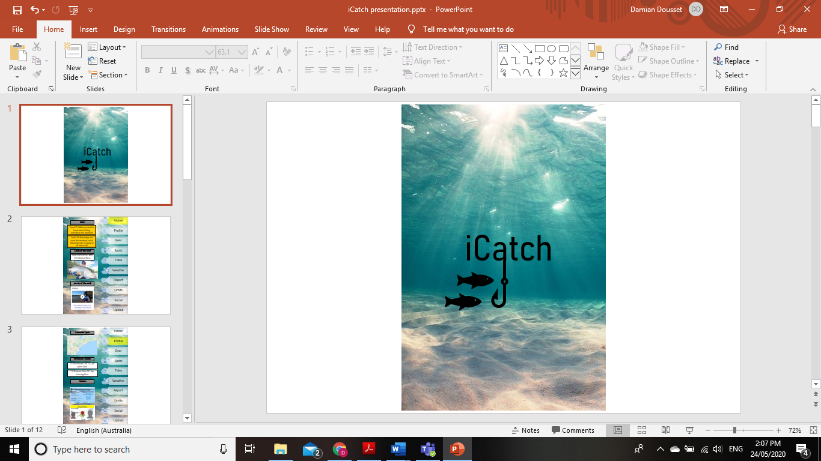 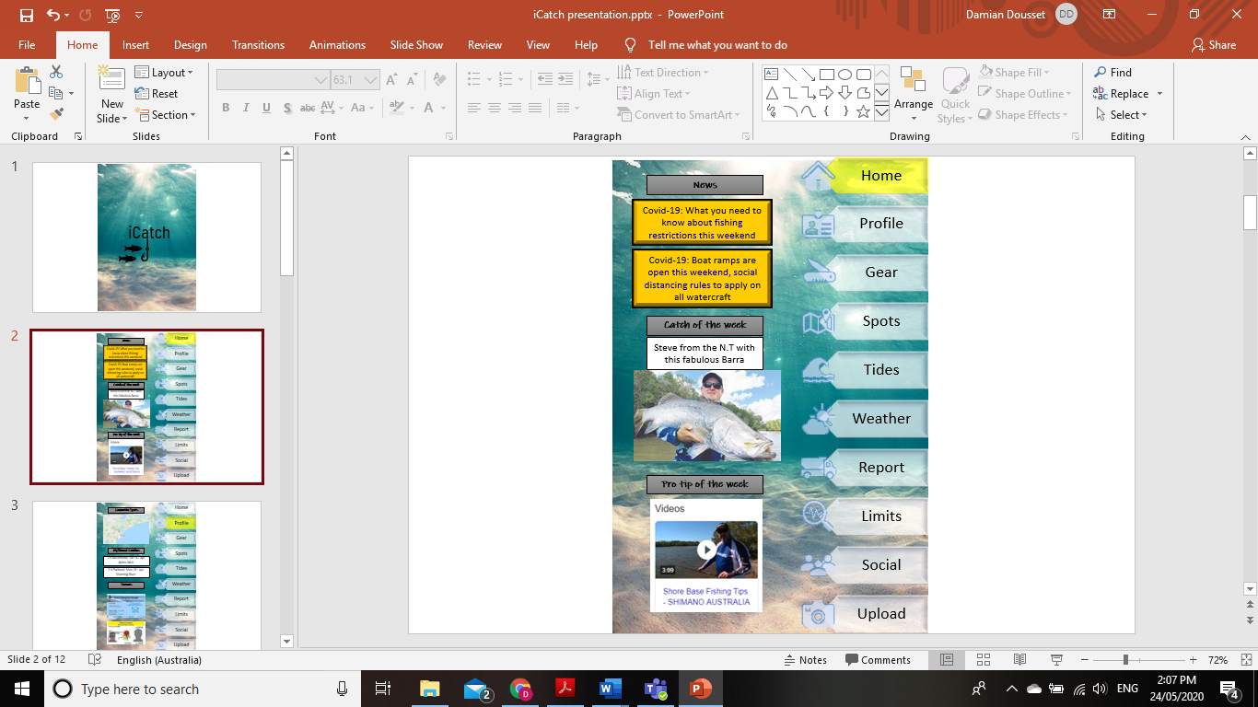

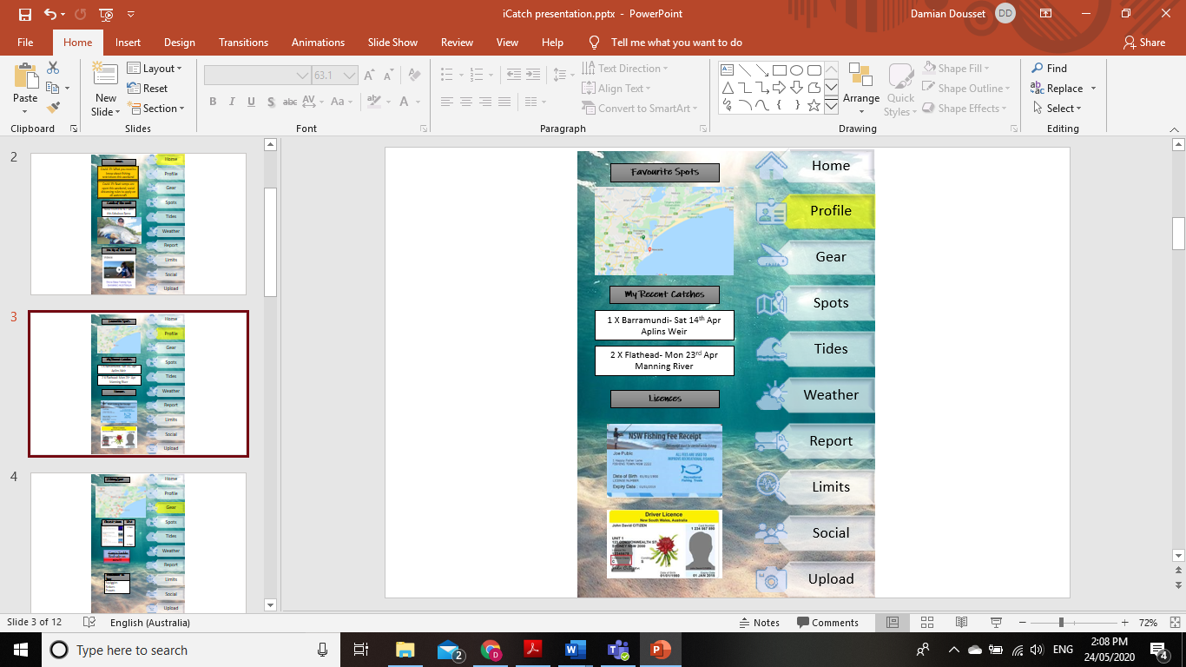 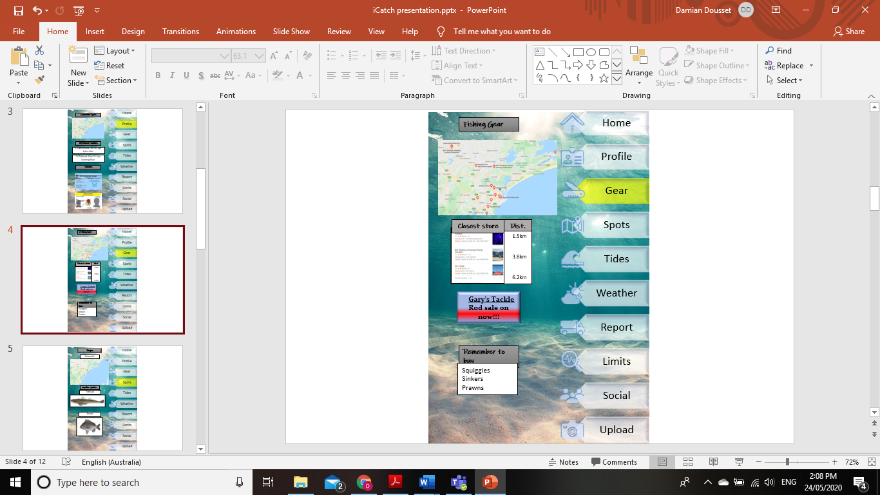

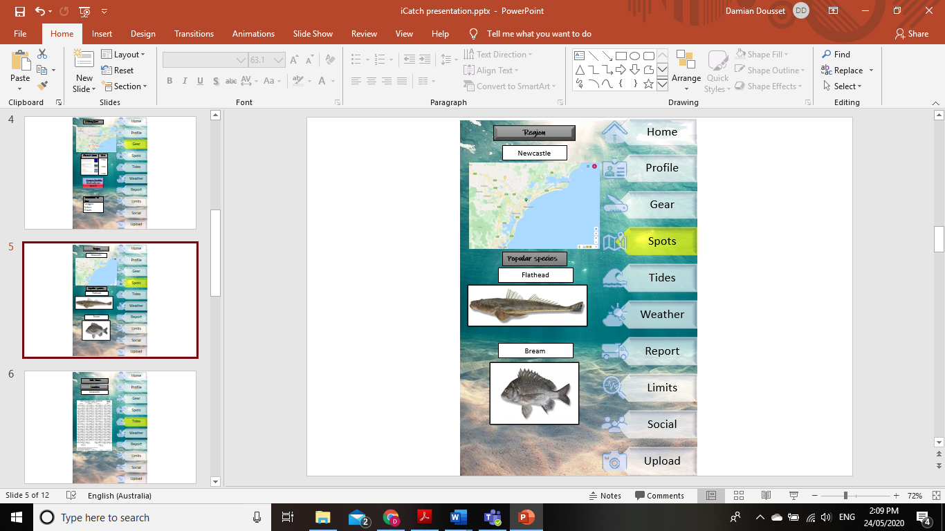 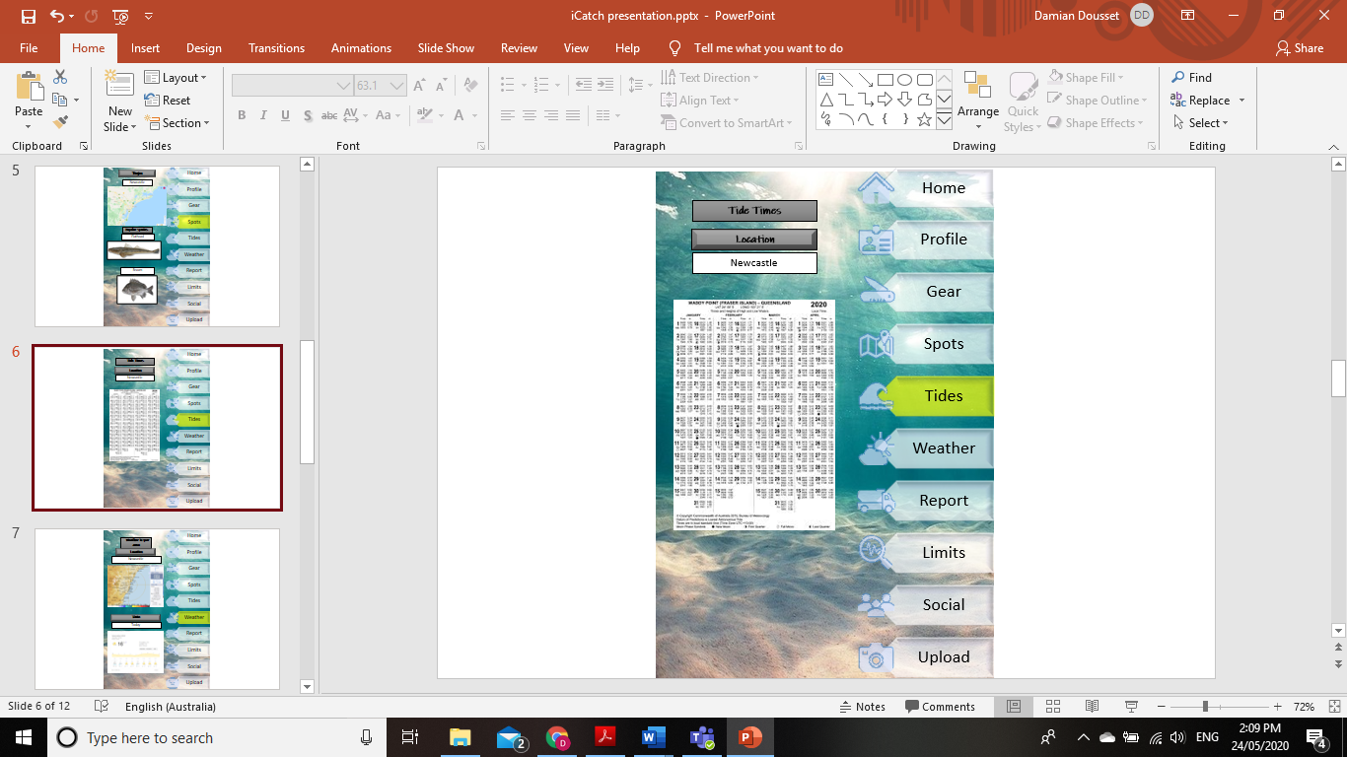

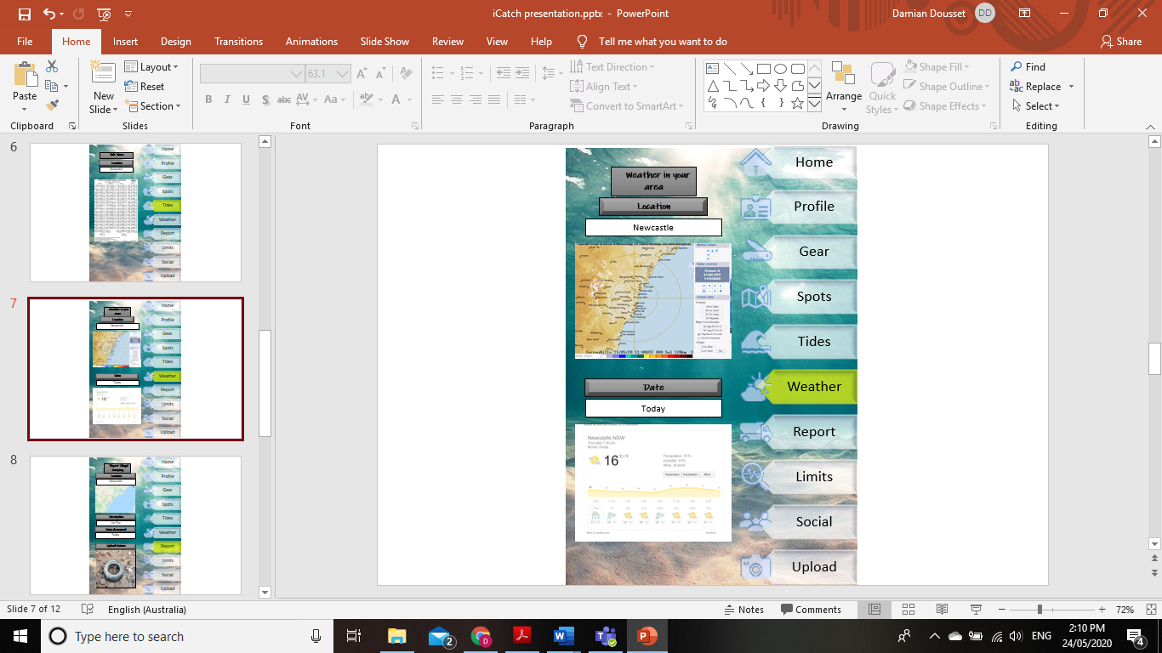 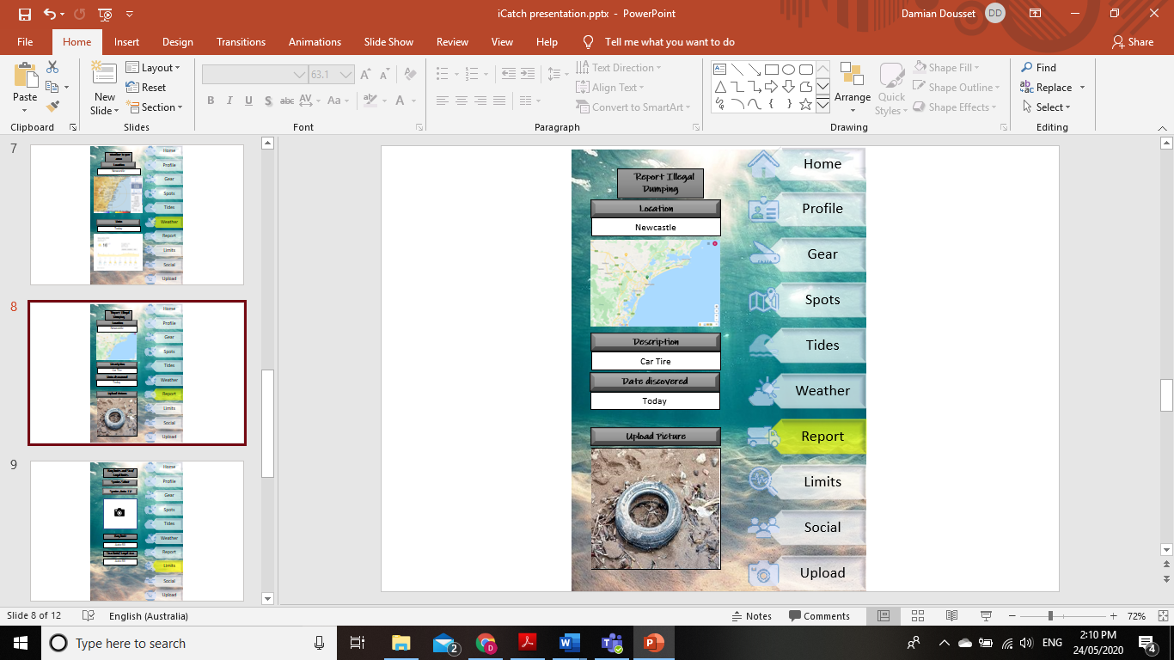

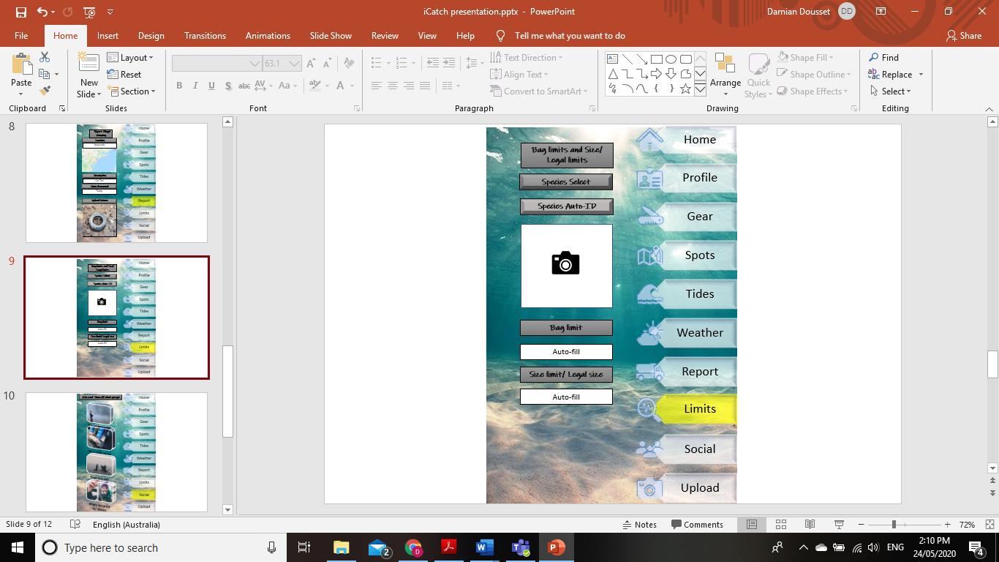 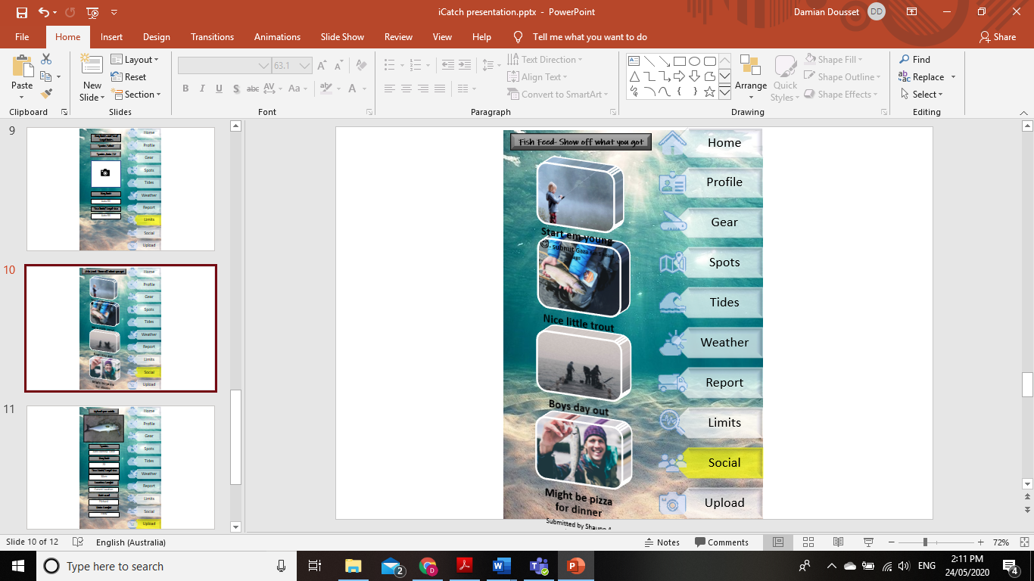

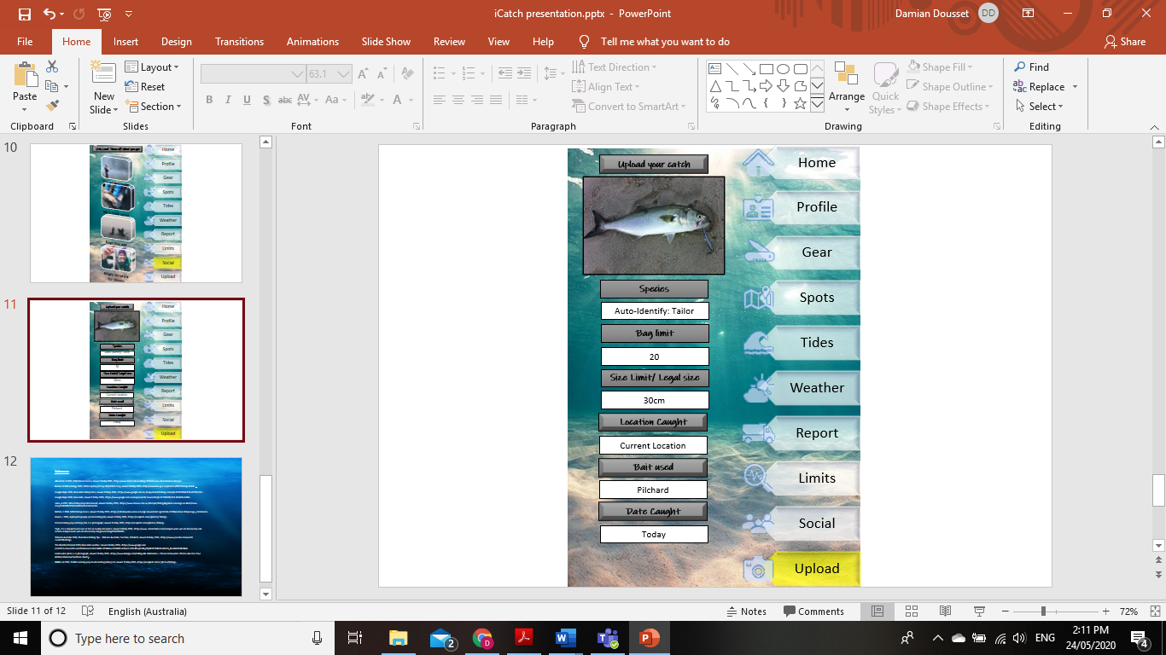

# Appendix 4 - artefact references

Alexander, R 2019, *NSW Drivers licence,* viewed 15 May 2020, <https://www.ltrent.com.au/blog/ different-nsw-driver-licence-classes/>.

Bureau of Meteorology 2020, *128 km Sydney (Terrey Hills) Radar Loop, viewed 14 May 2020,* <http://www.bom.gov.au/products/IDR713.loop.shtml>.

Google Maps 2020, *Newcastle Fishing Store*, viewed 11 May 2020, <https://www.google.com.au /maps/ search/fishing+store/@-32.8214568,151.619756,11z>.

Google Maps 2020, *Newcastle*, viewed 11 May 2020, <https://www.google.com.au/maps/search/newcastle /@-32.5904706,151.3493495,8.88z>.

Julius, A 2017, *Man holding large Barramundi*, viewed 14 May 2020, <https://www.ntnews.com.au/ lifestyle /fishing/big-barra-converge-on-klash/news-story/114038b72f35f2a18e0ac4a7de1dadd1>.

Nichols, S 2018, *NSW Fishing licence*, viewed 15 May 2020, <https://scholarworks.umass.edu/cgi/ view content.cgi?article=2211&context=fishpassage_conference>.

Owens, J 2016, *depth photography of man holding fish,* viewed 11 May 2020, <https://unsplash.com/s/photos/ fishing>.

*Person holding gray and beige fish*, n.d. photograph, viewed 11 May 2020, <https://unsplash.com/s/photos /fishing>.

Sayin, C n.d, *Dumped worn wet car tire on muddy soil surface*, viewed 14 May 2020, <https://www. dreamstime.com/dumped-worn-wet-car-tire-muddy-soil-surface-dumped-worn-wet-car-tire-muddy-soil-ground-image154016668>.

Shimano Australia 2016, Shore Base Fishing Tips – Shimano Australia, YouTube, 10 March, viewed 14 May 2020, <https://www.youtube.com/watch ?v=rhJTDUtOJ7g>.

The Weather Channel 2020, *Newcastle weather*, viewed 14 May 2020, <https://www.google.com /search ?q=newcastle+weather&source=lmns&bih=625&biw=1366&hl=en&ved=2ahUKEwjZtvKLg7PpAhVEf30KHdo3BdcQ_AUoAHoECAEQAA>.

*Underwater photo*, n.d. photograph, viewed 11 May 2020, <https://www.livingly.com/Calling+All +Mermaids+-+These+Underwater+ Photos+Are+For+You/Articles/stkeesSwn5e/Peace+Quiet >.

Wilkins, B 2019, *Toddler wearing gray hoodie holding fishing rod*, viewed 11 May 2020, <https://unsplash. com/s/photos/fishing>.